**ICT 2105: Numerical Analysis**

**Newton-Raphson Method**

Let x0 be an approximate root of the equation f(x) = 0

and

Let x = x0 + h be an exact root so that f(x0 + h) = 0, where h being a small quantity.

Now expanding f(x0 + h) by Taylor’s series, we get –

f(x0 + h) = f(x0) + hf’(x0) + hf’’(x0) + …….

f(x0) + hf’(x0) + f’’(x0) = 0 ∵ x0 + h = 0

Since h is very small, neglecting the second and higher order terms of h, we obtain an approximate value of h say h from the above equation.

f(x0) + h1f’(x0) = 0 ⇒ h1 = - ………. …. (1)

A better approximation than x0 is therefore may lie at x1 where

x1 = x0 + h1

x1 = x0 - ………….. from (1)

Now using x1 in the place of x0 and x2 in the place of x1 we get

Now replace x1 for x0

and x2 for x1

x2 = x1 - , which is little better than before e.g. x1.

Similarly

X3 = x2 - , which is little better than x2.

….. …… …… …… ……. ……. ……. ……

….. …… …… …… ……. ……. ……. ……

Continuing like this, we iterate this process until

Xn+1 = xn - , where n = 0,1,2,3,………

This method of successive approximation is called the Newton-Raphson Method.

The method can be used for both algebraic and transcendental equations and works for complex equation with complex coefficients.

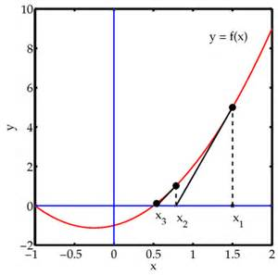

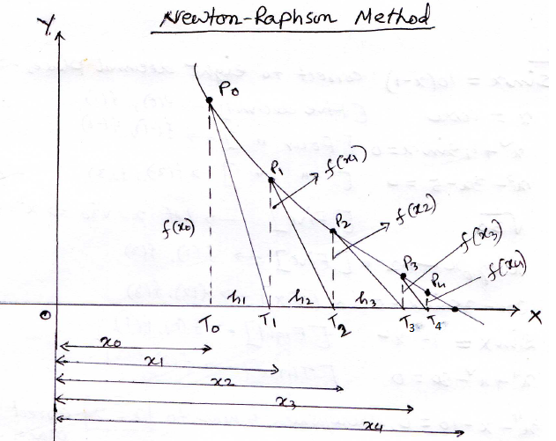

**Examples of NR(Newton-Rapson Method):**

**Ex-1:** Find the root of ${ 2x}^{3}-3x-6=0$ by NR method correct to **five** decimal places.

**Solution:** let, $f\left(x\right)=2x^{3}-3x-6 so, f^{'}\left(x\right)=6x^{2}-3$

$$here, f\left(1\right)=-7<0 ; f\left(2\right)=4>0$$

So, at least one root lies between 1 and 2. $⇒x_{0}=1.5$

Now by NR method, we get:

$$x_{n+1}=x_{n}-\left(\frac{f\left(x_{n}\right)}{f^{'}\left(x_{n}\right)}\right)=x_{n}-\frac{2x_{n}^{3}-3x_{n}-6}{6x_{n}^{2}-3}=\frac{6x_{n}^{3}-3x_{n}-2x_{n}^{3}+3x_{n}+6}{6x_{n}^{2}-3}$$

$$⇒x_{n+1}=\frac{4x_{n}^{3}+6}{6x_{n}^{2}-3}……………………..\left(1\right)$$

From (1) putting $x_{0}=1.5$ we get,

$$x_{1}=\frac{4x_{0}^{3}+6}{6x_{0}^{2}-3}=\frac{4{\left(1.5\right)}^{3}+6}{6{\left(1.5\right)}^{2}-3}=1.85714$$

$$x_{2}=\frac{4x_{1}^{3}+6}{6x_{1}^{2}-3}=\frac{4{\left(1.85714\right)}^{3}+6}{6{\left(1.85714\right)}^{2}-3}=1.78711$$

$$x_{3}=\frac{4x_{2}^{3}+6}{6x_{2}^{2}-3}=\frac{4{\left(1.78711\right)}^{3}+6}{6{\left(1.78711\right)}^{2}-3}=1.78373$$

$$x_{4}=\frac{4x_{3}^{3}+6}{6x_{3}^{2}-3}=\frac{4{\left(1.78373\right)}^{3}+6}{6{\left(1.78373\right)}^{2}-3}=1.78377$$

$$x_{5}=\frac{4x_{4}^{3}+6}{6x_{4}^{2}-3}=\frac{4{\left(1.78377\right)}^{3}+6}{6{\left(1.78377\right)}^{2}-3}=1.78377$$

Hence, the required root is 1.78377.

**Ex-2:** Find the root of $x^{3}=6x-4$ correct to **Five** decimal places by NR method.

**Solution:** let, $f\left(x\right)=x^{3}-6x+4 so, f^{'}\left(x\right)=3x^{2}-6$

Here, f(0)=4>0 and f(1)=-1<0 .

So, at least one root lies between o and 1. $⇒x_{0}=0.75$

Now, by NR method we get,

$$x_{n+1}=x_{n}-\frac{f\left(x_{n}\right)}{f^{'}\left(x_{n}\right)}=x_{n}-\frac{x_{n}^{3}-6x_{n}+4}{3x_{n}^{2}-6}=\frac{2x_{n}^{3}-4}{3x_{n}^{2}-6}………….\left(1\right)$$

Taking $x_{0}=0.75$ the relation (1) gives,

$$x_{1}=\frac{2{\left(x_{0}\right)}^{3}-4}{3{\left(x_{0}\right)}^{2}-6}=\frac{2{\left(0.75\right)}^{3}-4}{3{\left(0.75\right)}^{2}-6}=0.72188$$

$$x_{2}=\frac{2{\left(x_{1}\right)}^{3}-4}{3{\left(x_{1}\right)}^{2}-6}=\frac{2{\left(0.72188\right)}^{3}-4}{3{\left(0.72188\right)}^{2}-6}=0.73205$$

$$x_{3}=\frac{2{\left(x_{2}\right)}^{3}-4}{3{\left(x_{2}\right)}^{2}-6}=\frac{2{\left(0.73205\right)}^{3}-4}{3{\left(0.73205\right)}^{2}-6}=0.73205$$

so, the required root is $0.73205$**.**

**Ex-3** Find the root of 3x-cosx-1=0 by Newton-Raphson method correct to **six** decimal places.

**Solution:** Let, f(x) =3x-cosx-1

So, f ’(x) = 3+sinx

Here, f(0) = 0-0-1 <0

And f(1) = 3-cos(1)-1 = 1.45970 >0

So, one root lies between 0 and 1.

Now, by NR method we get:

$$x_{n+1}=x_{n}-\frac{f\left(x_{n}\right)}{f^{'}\left(x_{n}\right)}=x_{n}-\frac{3x_{n}-\cos{x_{n}}-1}{3+\sin{x_{n}}}=\frac{x_{n}\sin{x_{n}}+\cos{x_{n}}+1}{3+\sin{x_{n}}}…………….\left(1\right)$$

Taking $x_{0}=0.5$ the relation (1) gives,

$$x_{1}=\frac{x_{0}\sin{x_{0}}+\cos{x_{0}}+1}{3+\sin{x_{0}}}=\frac{0.5\sin\left(0.5\right)+\cos\left(0.5\right)+1}{3+\sin\left(0.5\right)}=0.60852$$

$$x_{2}=\frac{x_{1}\sin{x_{1}}+\cos{x_{1}}+1}{3+\sin{x_{1}}}=\frac{0.60852\sin\left(0.60852\right)+\cos\left(0.60852\right)+1}{3+\sin\left(0.60852\right)}=0.60710$$

$$x_{3}=\frac{x_{2}\sin{x_{2}}+\cos{x_{2}}+1}{3+\sin{x_{2}}}=\frac{0.60710\sin\left(0.60710\right)+\cos\left(0.60710\right)+1}{3+\sin\left(0.60710\right)}=0.60710$$

So, The required root is: $0.60710$**.**

**Ex-4:** Find the root of $\cos{x}-xe^{x}=0$ by NR.

**Solution:**

Let, $f\left(x\right)=\cos{x}-xe^{x} so, f^{'}\left(x\right)=-\sin{x}-e^{x}-xe^{x}$

Here, f(0)=1>0 and f(1)=-2.17798<0 so, one root lies between 0 and 1.

By NR method we get,

$$x_{n+1}=x_{n}-\frac{f\left(x_{n}\right)}{f^{'}\left(x_{n}\right)}=x_{n}-\frac{\cos{x_{n}}-x_{n}e^{x_{n}}}{-\sin{x_{n}}-e^{x_{n}}-x_{n}e^{x_{n}}}=\frac{x_{n}\sin{x_{n}}+x_{n}^{2}e^{x_{n}}+\cos{x_{n}}}{\sin{x_{n}}+e^{x_{n}}+x_{n}e^{x_{n}}}……(1)$$

Taking $x_{0}=0.5$ we get from (1)

$$x_{1}=\frac{x_{0}\sin{x_{0}}+x_{0}^{2}e^{x_{0}}+\cos{x_{0}}}{\sin{x_{0}}+e^{x_{0}}+x_{0}e^{x_{0}}}=\frac{0.5\sin{0.5}+{0.5}^{2}e^{0.5}+\cos{0.5}}{\sin{0.5}+e^{0.5}+0.5e^{0.5}}=0.51803$$

$$x_{2}=\frac{x_{1}\sin{x_{1}}+x_{1}^{2}e^{x_{1}}+\cos{x_{1}}}{\sin{x_{1}}+e^{x_{1}}+x_{1}e^{x_{1}}}=\frac{0.51803\sin{0.51803}+{0.51803}^{2}e^{0.51803}+\cos{0.51803}}{\sin{0.51803}+e^{0.51803}+0.51803e^{0.51803}}=0.51776$$

$$x_{3}=\frac{x_{2}\sin{x_{2}}+x_{2}^{2}e^{x_{2}}+\cos{x_{2}}}{\sin{x_{2}}+e^{x_{2}}+x_{2}e^{x_{2}}}=\frac{0.51776\sin{0.51776}+{0.51776}^{2}e^{0.51776}+\cos{0.51776}}{\sin{0.51776}+e^{0.51776}+0.51776e^{0.51776}}=0.51776$$

So the required root is: $0.51776.$

**Exercise for NR method:**

1. $\sin{x}=10(x-1)$ correct to eight decimal places ⇒ f(1),f(2)
2. $x=\cos{x}$ [five decimal] ⇒ f(0), f(1)
3. $x^{2}+4\sin{x}=0$ [Four decimal] ⇒ f(-1), f(-2)
4. $x^{3}-3x-5=0$ [Four decimal] ⇒ f(2), f(3)
5. $\sqrt{30} ;(let x=\sqrt{30} ⇒x^{2}=30⇒x^{2}-30=0)$ [Five decimal] ⇒ f(5), f(6)
6. $xlog_{10}x-1.2=0$ [Five decimal] ⇒ f(2), f(3)
7. $2x-3\sin{x}-5=0$ [Six decimal] ⇒ f(1), f(2)
8. $\sin{x}=1-x^{2}$ [Eight decimal] ⇒ f(0), f(1)
9. $x^{4}+x^{2}-80=0$ [Three decimal] ⇒ f(2), f(3)
10. $x^{4}-x-10=0$, where/which is near to x=2 [Three decimal] ⇒ f(1), f(2)